WebSite implementation report

Photography Website

University of Queensland

DECO1400

# Summary of Implementation

## HTML

The website used four html files to implement each of the respective pages: index, about, work, contact. These files all followed a similar structure that included the top navigation bar, the main body of content, and a footer.

## CSS

The overall CSS for the website was divided into separate files, each linked to their respective html pages. This was to ensure clarity and accessibility when finding specific styling and only focusing on a particular page.

### Design Changes

A few design choices that were initially proposed in the high-fi prototype were modified in the final design, which was then directly implemented in CSS. A major change was the site’s landing page and design. Although the main body and overall structure follows the prototype, the final design has a transparent navigation bar and has its content overlayed using a parallax effect (see JavaScript section).

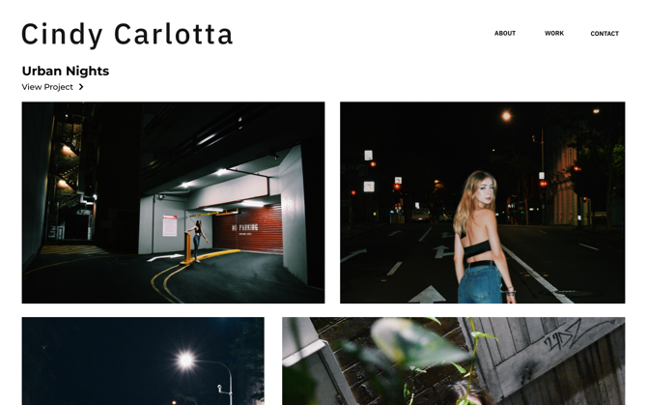

The footer colour was also modified to reflect a monochromatic colour palette for the landing page so that users could focus their attention on the main content of the website, such as the photography showcased. Additionally, the footer navigation menu featured an underline for users hovering over the link, to ensure clarity and accessibility.

### Heuristic Applications

CSS was used to improve visibility and accessibility in many other aspects of the website implementation. Such as the top navigation bar, in which hovering over the menu item will increase the opacity of the item name. Not only does this ensure clear and concise navigation, but also a clean and minimalist design.

CSS was also used to achieve the enlarge-effect that was triggered upon hovering gallery images.

## JavaScript

The JavaScript used for the entire website implementation was combined in one file, unlike the organisation of the HTML and CSS files.

These included three notable JavaScript interactions:

1. The main and most predominate interaction is seen upon landing—a **parallax** **scroll** effect. This effect works dynamically and was adapted from Ndaw’s publication (I. Ndaw, 2019).

The effect involves two containers that move as the user scrolls vertically through the page. This was adapted and modified to remain consistent with the theme and positioned upon the first page-load. A bounce and fade animation were also used in conjunction with this effect.

1. **Dynamic Navigation Menu**

Video Demo

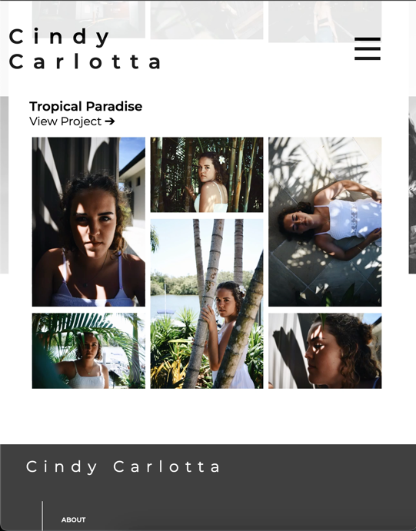

A dynamic navigation menu was used for a responsive design when viewed on a mobile or tablet device. The navigation fades in and out when the ‘burger’ menu icon is clicked. This menu icon is also animated to transform into a cross, so that there is user control.

This interaction was based on DevEd (2018) but modified to be full-screen and negated certain text animations.

1. **Automated Slideshow**

The automated slideshow is the main content on the Work page. It features stand-out images from the photography portfolio and is automated to a set interval.

The user also has the option to manually switch between image slides using the navigation bar. This interaction was adapted from Coding Snow (2021).

# Website Screenshots

## Laptop View (default)

Home Page

Contact Page

Work Page

About Page

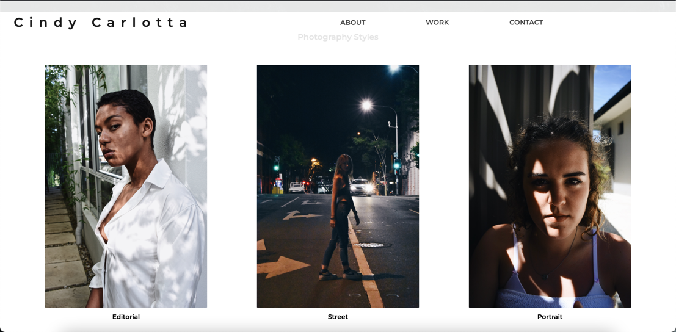

## A picture containing text Description automatically generatedGraphical user interface, application Description automatically generatedA picture containing text, different, posing, set Description automatically generatedGraphical user interface Description automatically generatedGraphical user interface, application Description automatically generatedA person with long hair Description automatically generated with medium confidenceTablet & Mobile View (max-width 768px)

# Challenges & Lessons

Throughout the implementation of the design, a few challenges were faced, such as the image gallery container as seen on the main page.

The challenge was formatting the images and its layout without affecting its aspect ratio.

# Evaluation using Nielsen’s Heuristics

As mentioned in previous sections, many of the design choices made in the final website implementation considered Nielsen’s heuristics.

Some implementations include:

* Match between system and real world

Universal icons and symbols were used in the design and navigation of the website. These included the camera and picture icons (about.html) and the social media logos in the footer navigation.

* Consistency and standards

Consistency to a particular colour scheme and theme is seen throughout the various pages. In which they all follow a relatively monochromatic colour scheme, as previously discussed. Styling choices were also consistent, such as font-size and style.

* Error prevention and user control & freedom

Error prevention is seen when toggling the navigation menu on a tablet/mobile device. This included clear navigation icons if the user wished to close the window.

* Recognition rather than recall

The overall format and structure of the pages followed a standard that is already seen commonly. Thus, the user can easily recognise how to navigate through the website. This includes having a top navigation bar and a footer, that is separated by the main content.

* Aesthetic and minimalist design

The overall theme followed a minimalist style by maintaining a monochromatic scheme and accents. Only the necessary elements and styling was included, as to focus the user’s attention on the photography.

# Conclusion

The final website design was implemented through HTML, CSS, and JavaScript. Although a few design choices were modified from the prototypes, the design remained predominately consistent with it. A few of the modifications were with consideration of the usability heuristics, in which most, if not all, can be seen in use.

# References

UICONS, flaticon. Retrieved via https://www.flaticon.com/uicons

Nielsen. J (2020) *10 Usability Heuristics for User Interface Design*. Retrieved via https://www.nngroup.com/articles/ten-usability-heuristics/

Dev Ed. (2018) *Responsive Navigation Bar Tutorial | HTML CSS JAVASCRIPT.* YouTube. https://www.youtube.com/watch?v=gXkqy0b4M5g

Ndaw, I. (2019) *Make a parallax effect with 10 lines of JavaScript*. Retrieved via https://dev.to/ibrahima92/make-a-parallax-effect-with-10-lines-of-javascript-3hia

Rogov (2012), Unsplash, digital image. Retrieved via https://unsplash.com/photos/6boIc68nzMA

Coding Snow (2021) *Responsive Image Slider | With Manual Button & Auto-Play Navigation Visibility - HTML CSS Javascript.* Retrieved via https://www.codingsnow.com/2021/01/responsive-image-slider-with-manual.html